## Internal Non-Code QA

Internal non-code QA refers to the quality assurance processes for our research products *other than code* – for example, written reports, research notes, policy briefs, slide decks, and any other content that isn’t just programming output. Internal QA of our research work allows us to catch issues, incorporate insights from our team, and foster collaboration and institution-building. All of these factors combine to improve the quality, rigor, and credibility of our work.

In other words, internal QA is a key part of making sure our research tells a clear, accurate story and that it benefits from the collective wisdom of the institute. It also helps build a shared understanding within the team and helps newer members learn from more experienced colleagues in a natural way.

Checklists that reflect suggest standards when **creating**, **clearing**, and **presenting** work are given below. These standards should be read in relation to the e61 Communications Guidelines.

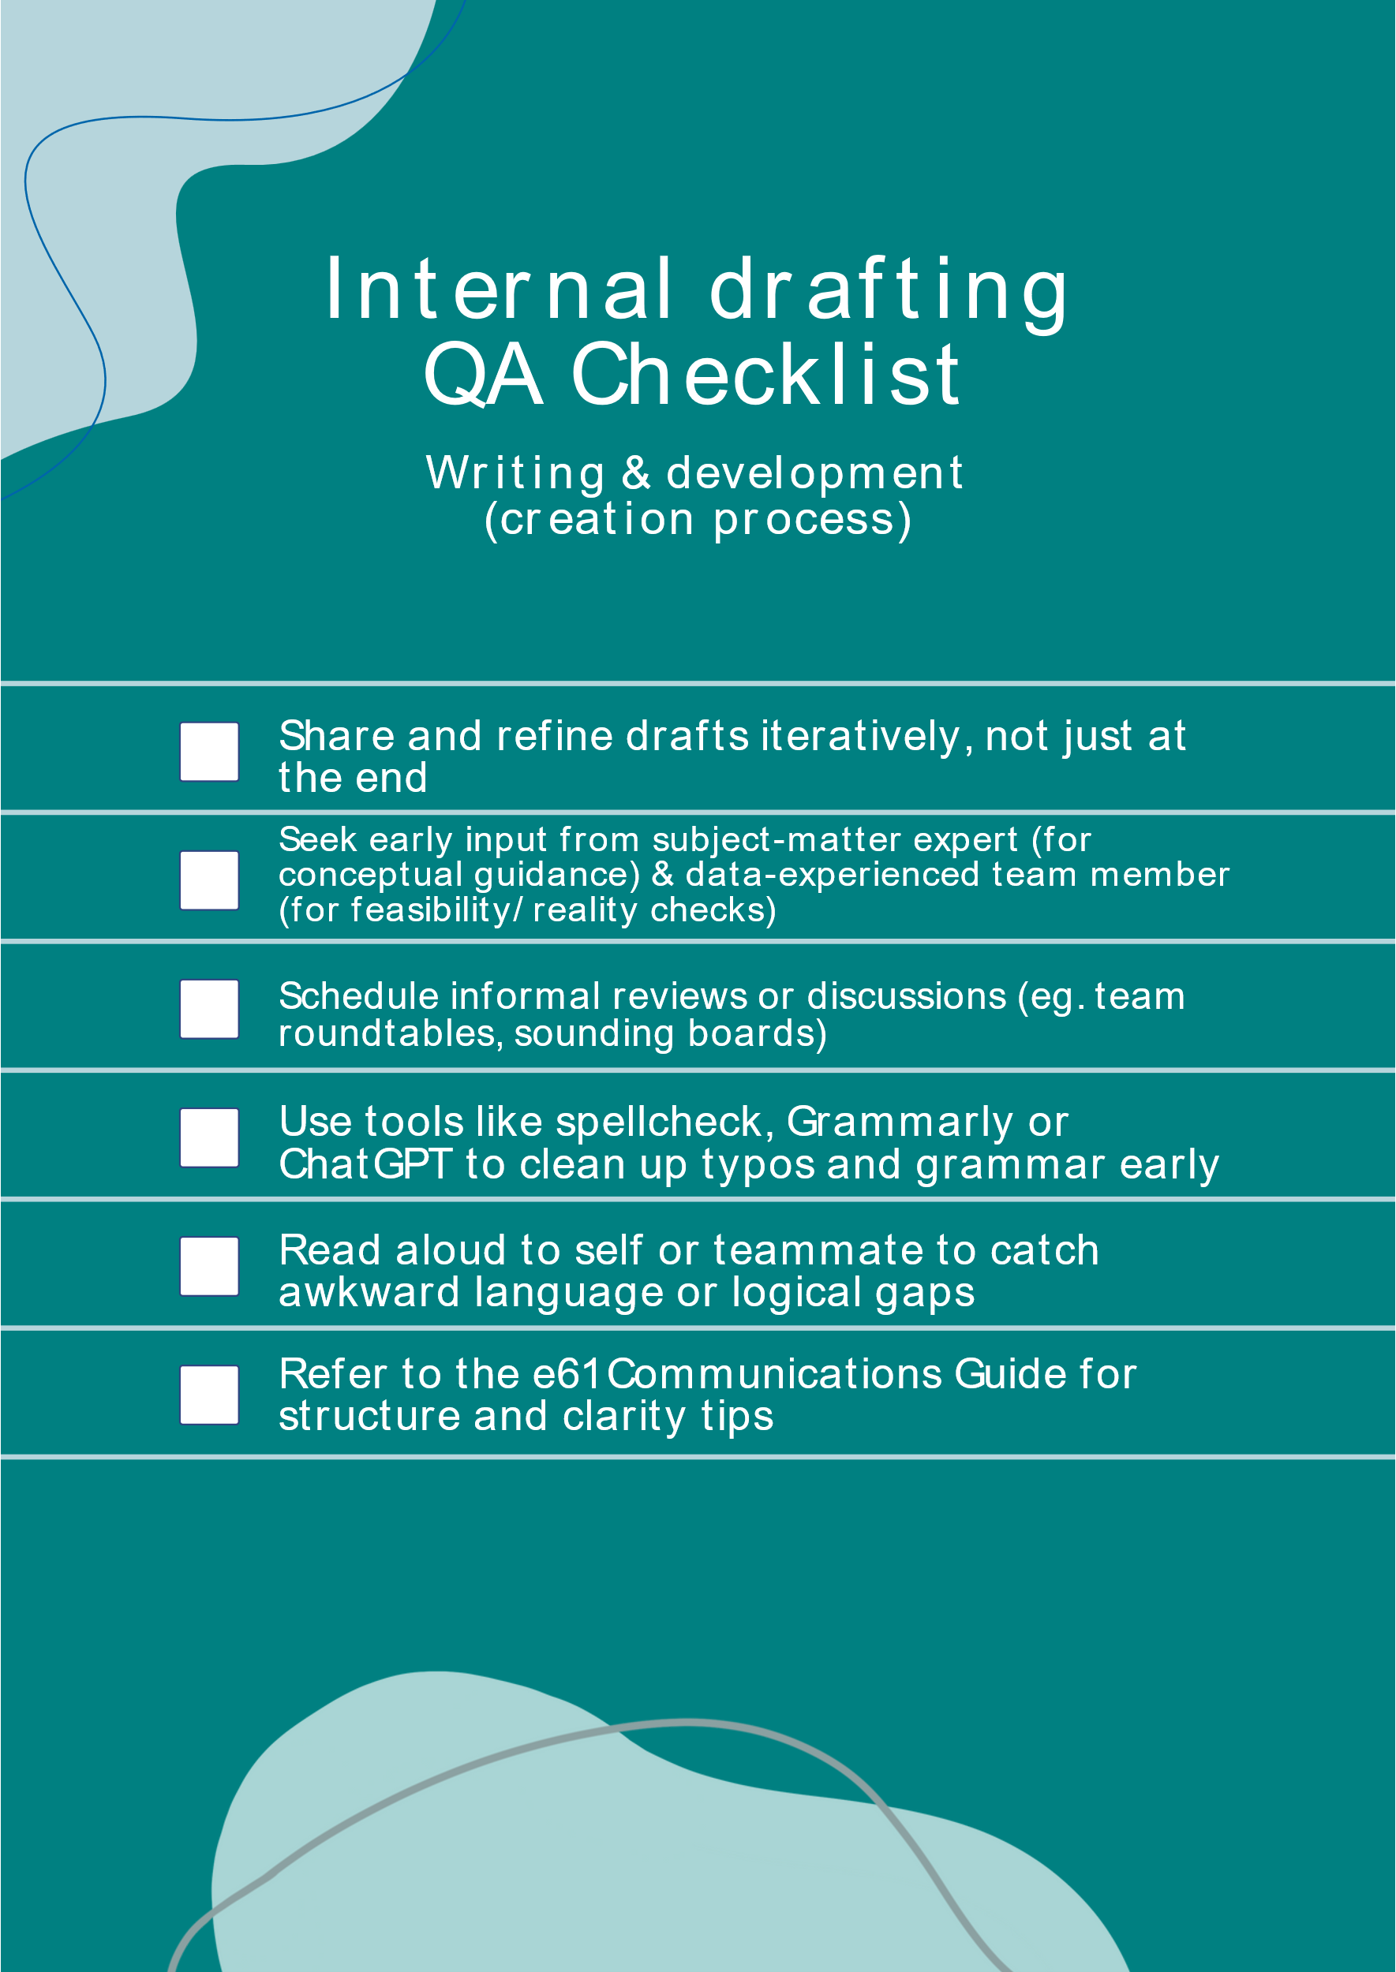

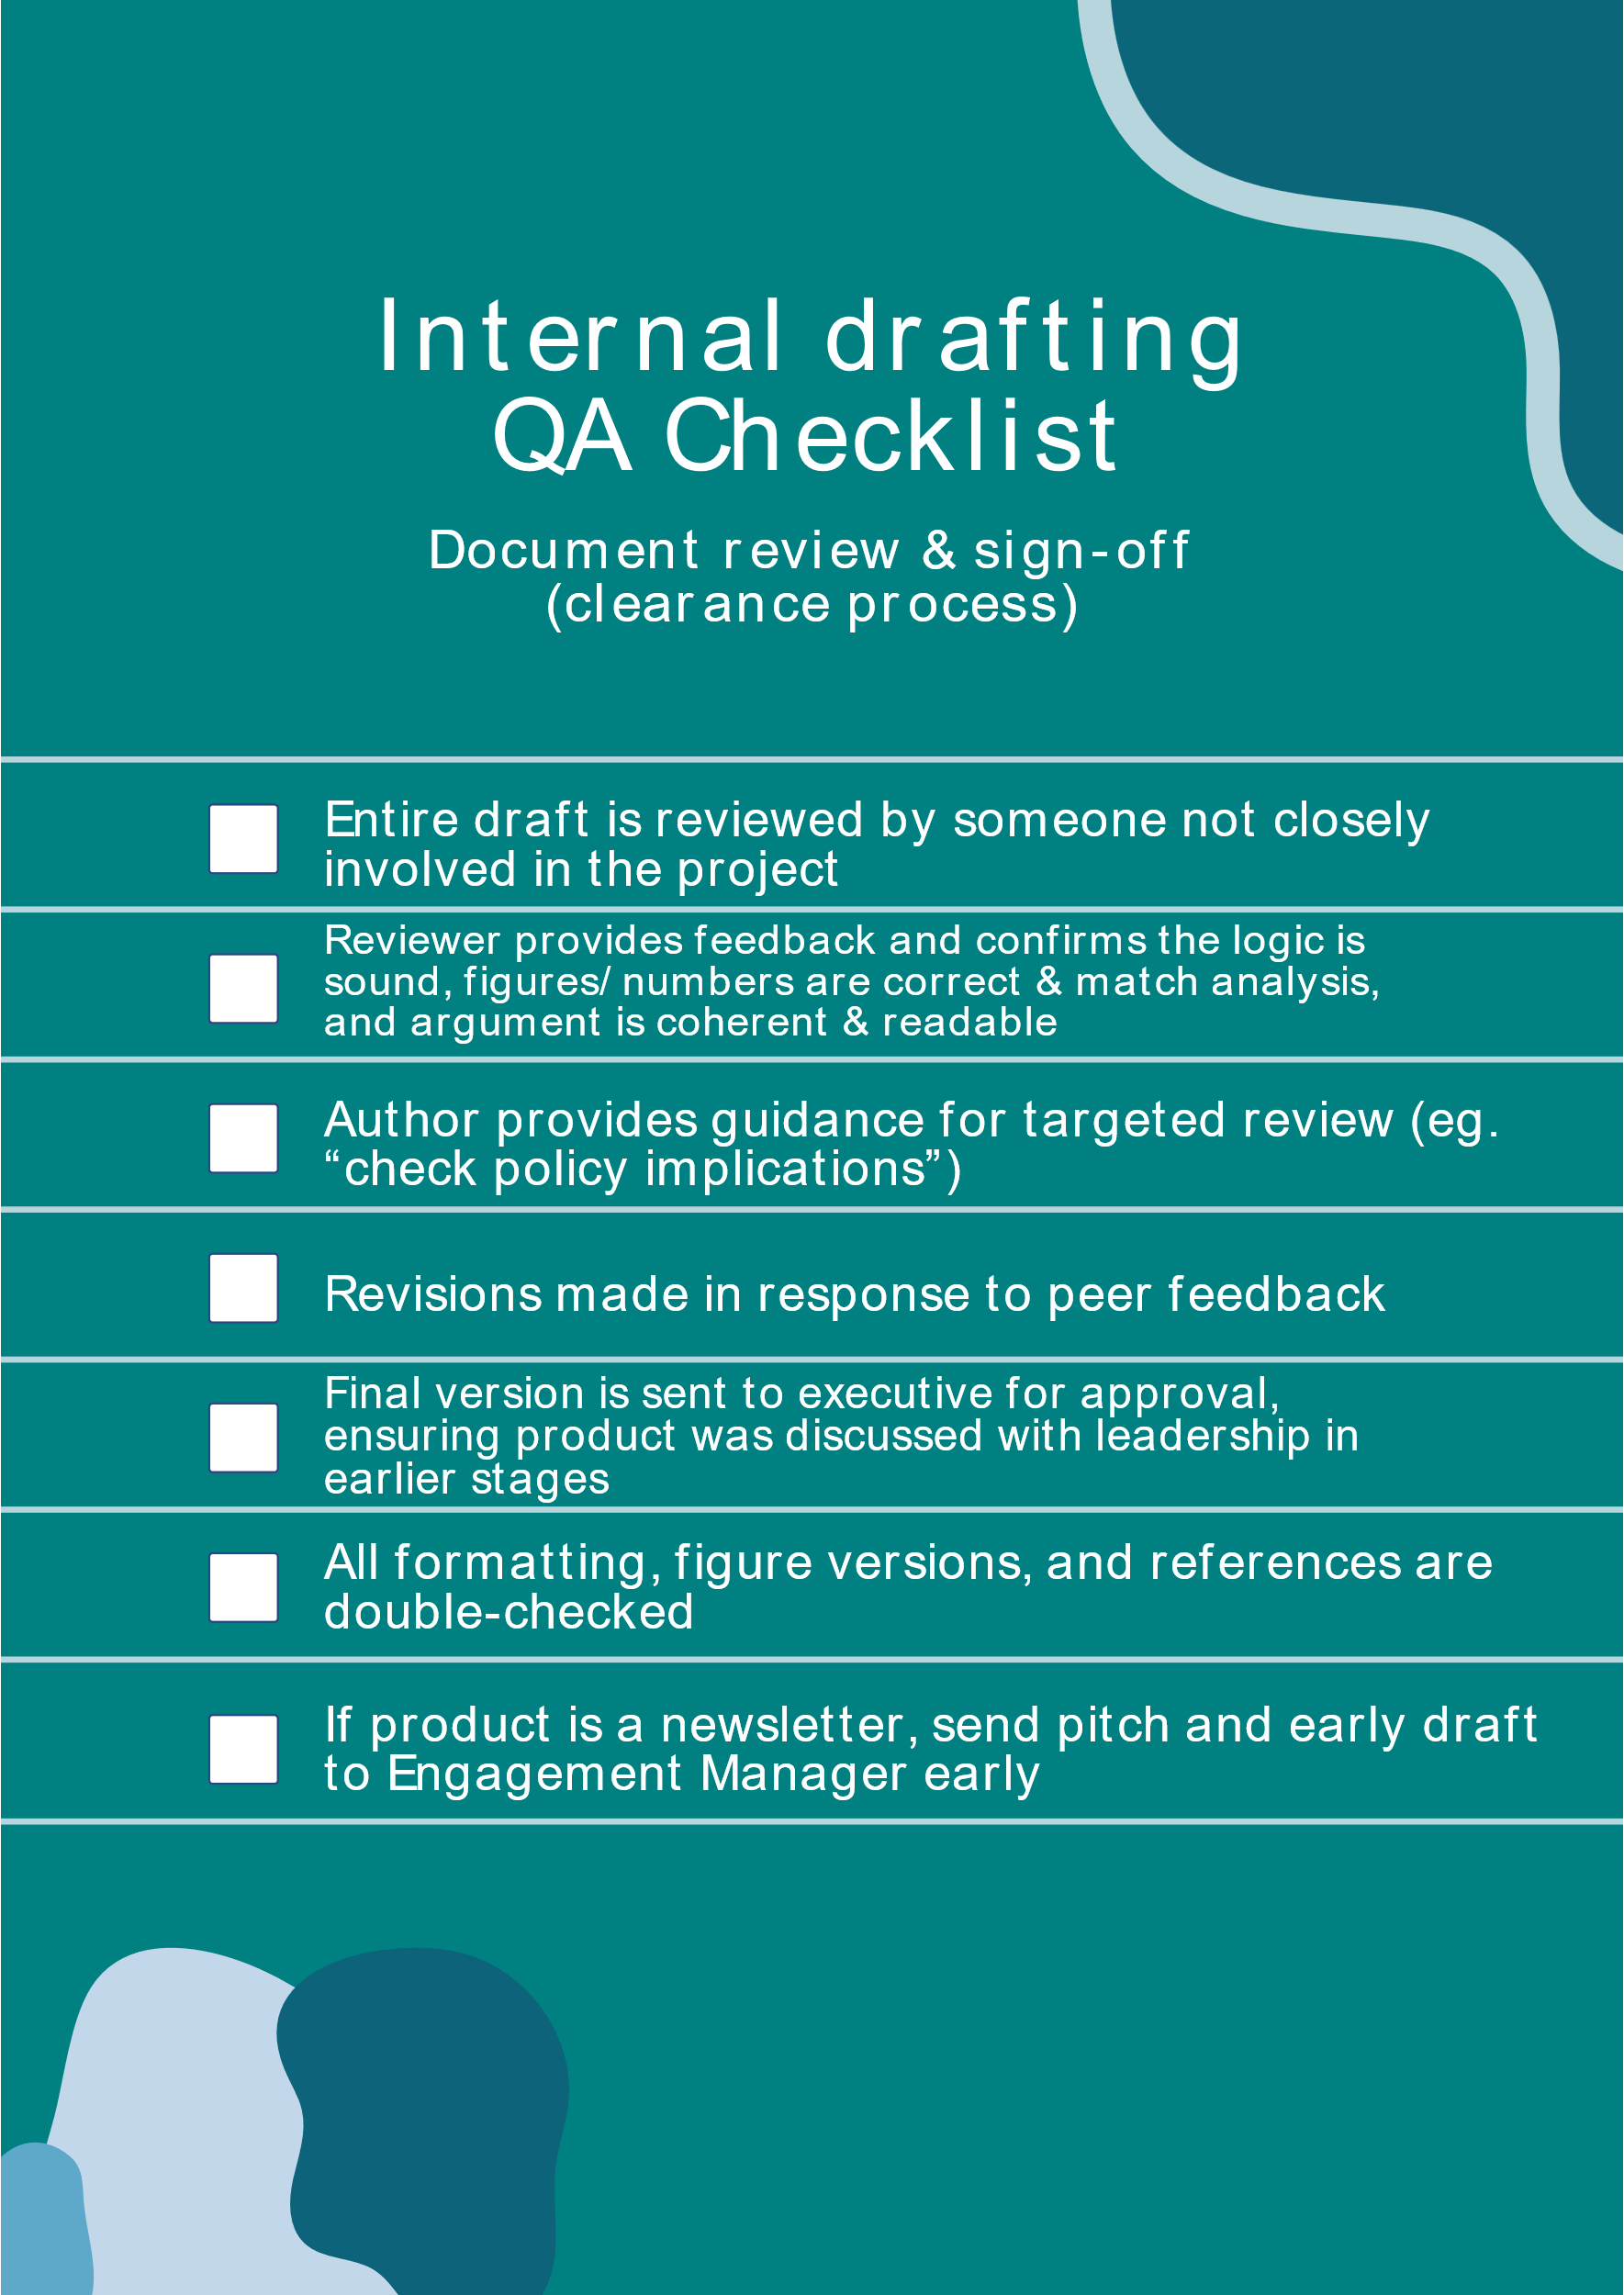

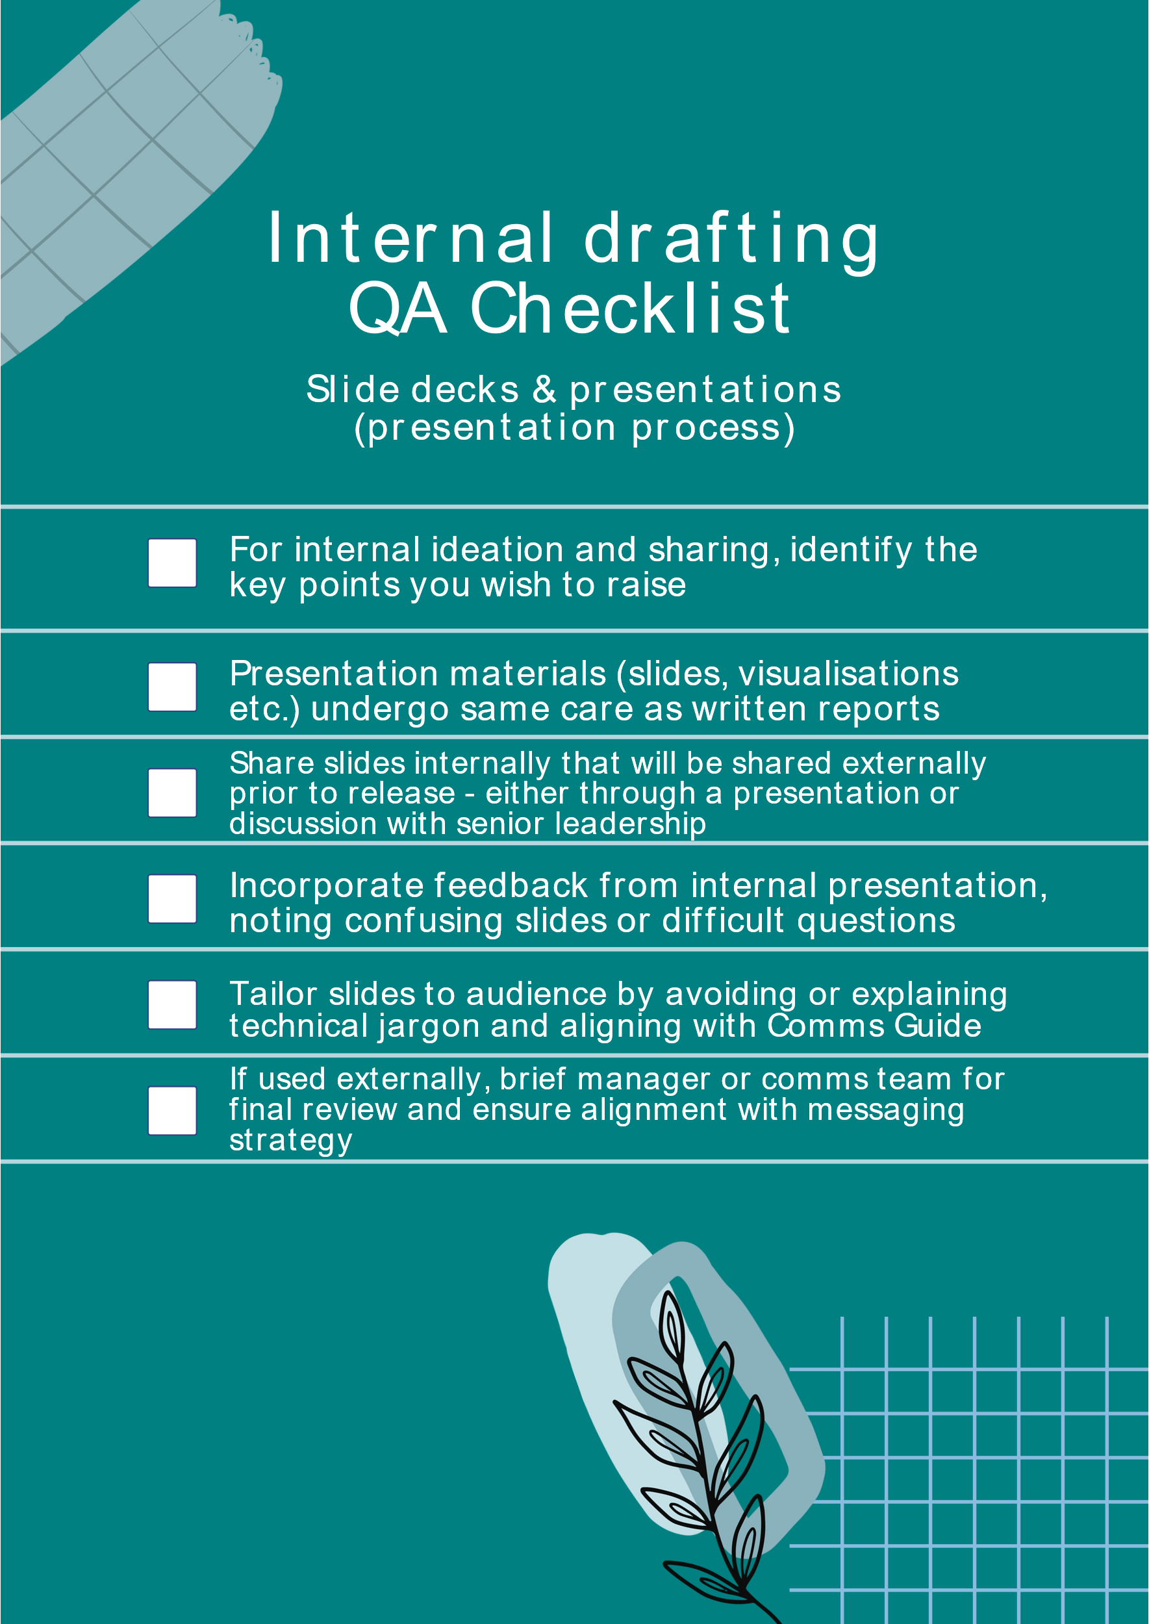

## Non-code QA motivation and explanation

Internal non-code QA can be split into three processes:

* **The creation process** of iteratively writing and developing ideas, and sharing them within the team (and the institute) as they take shape.
* **The clearance process** associated with the final review and approval of a product before its release.
* **The presentation process**, involving the production and QA of presentation materials (like slide decks) and the incorporation of feedback from internal presentations of the work.

Below we outline the structure of each process, so that teams can consider how to include these steps in their project planning and workflow.

**Creation Process**

The creation process for non-code outputs is essentially the *drafting and development stage* of your research product. This is where ideas are conceptualised, written down, and refined. Quality assurance at this stage means not working in isolation until a “perfect” draft emerges, but rather **iteratively sharing and refining your work** with input from others.

**Early feedback** helps ensure that the direction is sound – your teammates might spot a logical gap, suggest relevant literature or data, or identify where the focus could be sharpened. Incorporating insights from our team at this stage can save a lot of pain later by catching major issues early on.

A good practice is to schedule **informal internal reviews** as part of the creation phase. This could take many forms: asking a colleague to be a “sounding board” for your outline, doing a roundtable discussion of preliminary results at a team meeting, or sharing a partial draft for comments well before the deadline. The tone at this stage should be open and collaborative – it’s about improving the work, not judging it.

While seeking feedback, remember to keep it *focused*. **You don’t need to ask *everyone* for input on *everything***. Pick one or two people whose feedback would be most valuable for the stage you’re in – for example, someone with subject matter expertise for conceptual feedback, and someone with experience with the data to understand what is practical. This way you get quality input without getting overwhelmed by too many conflicting opinions.

In terms of low-cost QA practices in creation: even simple steps help. **Read your work aloud** to yourself or a teammate – this can catch awkward phrasing or logical leaps in an argument. Use tools like spellcheck, ChatGPT, and Grammarly early to clean up basic issues (no need to have colleagues flag typos that a tool could find). And refer to the **e61 Communications Guide** for structural tips.

**Clearance Process**

The clearance process is the more formal review stage that happens when your product (report, note, brief, etc.) is near-final and you’re preparing to release it. Think of this as the quality gate that every product should pass before it’s considered ready for the outside world. The clearance process typically includes internal peer review, leadership/executive review, and editorial checks. It’s meant to ensure the work is *sound, polished, and approval has been given* at the appropriate levels.

In practice, the clearance process often starts with a **peer or team review of the full draft**. By this point, you might have had bits and pieces reviewed during creation, but now someone (or a couple of people) should read the entire product end-to-end. Ideally, this **includes at least one person who hasn’t been deeply involved in the project** (a fresh perspective can spot inconsistencies or sections that need more clarity). They should verify the logic of the argument, the correctness of figures and facts (cross-checking numbers with the analysis/code outputs as needed), and overall coherence. It helps to provide your reviewer with guidance – for example, you might say, “Could you focus on whether the policy implications are clear and check if any part is confusing?” to target their attention.

After internal peer review and revising the draft, the next step is usually **managerial or executive clearance**. At e61, this means circulating the product to the Executive, including Greg Kaplan, for clearance. *Note*: The ideas and material should have been shared with Greg, and other executive members, before this stage for feedback in the creation stage.

When releasing a project, also **plan for a small buffer of time** between final approval and publication. The team is responsible for the final editorial quality of the product – and so authors must ensure formatting is correct, double-checking that all figures are the latest versions, etc. Use the **e61 Communications Guide** and any available checklists to do so.

Unlike other e61 products, **newsletters** are a bit unique: they are internal-written but external-facing, and they’re often on tight timelines (since they might be tied to current events or a schedule). For this reason, authors should aim to **provide a pitch and early draft to our Engagement Manager as soon as possible**.

By following a structured clearance routine, we significantly reduce the risk of mistakes or mishaps in our final products, reinforcing our credibility.

**Presentation Process**

The presentation process involves preparing and vetting the materials we use to present our work, as well as the act of presenting the research internally to gather feedback before external release. It overlaps with the clearance process but focuses specifically on *slide decks, presentations, and the feedback loop around presenting findings*.

Note that, for larger research and discussion of full e61 projects, multiple rounds of presentation should **proceed the clearance process** as part of creating economic research. Internal presentations that are intended for ideation are encouraged for projects, and the related slide decks can meet less rigorous quality standards than those described below.

When you prepare a **slide deck** or any visual presentation of your research, treat it with the same care as a written report – including verifying the information shared, reviewing for mistakes, and requesting peer review. Keep the **Communications Guide principles** in mind: slides should maintain clarity and be tailored to the audience, just like written communications (i.e. if the audience is general, ensure your slides avoid technical jargon or, if it’s unavoidable, that you explain it briefly).

The first use of a slide deck should generally be in an **internal presentation** – before we go out to stakeholders or the public with our findings. However, for rapid turnover work a **discussion with senior leadership** on the deck will suffice.

During the internal presentation, take note of the feedback and questions. Were there particular slides where people seemed confused? Was there a question you struggled to answer on the spot? Incorporating this feedback will make your external presentation far more effective and bullet-proof. Moreover, internal presentations are opportunities for **institutional learning**: other team members learn about what you did, which fosters a sense of teamwork and shared mission.

After the internal round, you might need a **clearance of the presentation materials** similar to document clearance. If the presentation (slides + talking points) is going to be used externally – say, at a conference or an official briefing – it is recommended you have a manager or the comms team quickly look over it after you’ve updated it post-feedback. They might catch any remaining issues and will ensure it aligns with any broader messaging strategy. This doesn’t have to be heavy; a short meeting to run through the final deck can suffice.